**Approve Application by HR**

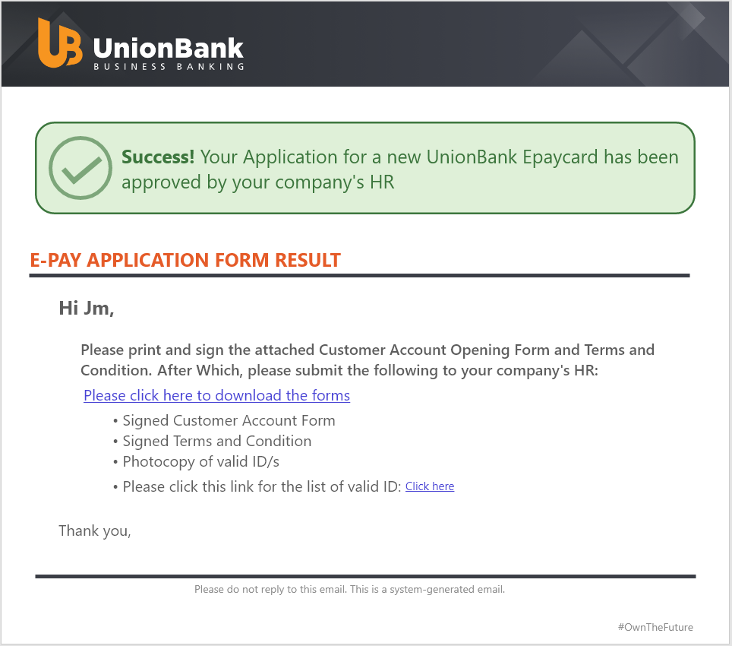

**APPLICATION FORM URL**

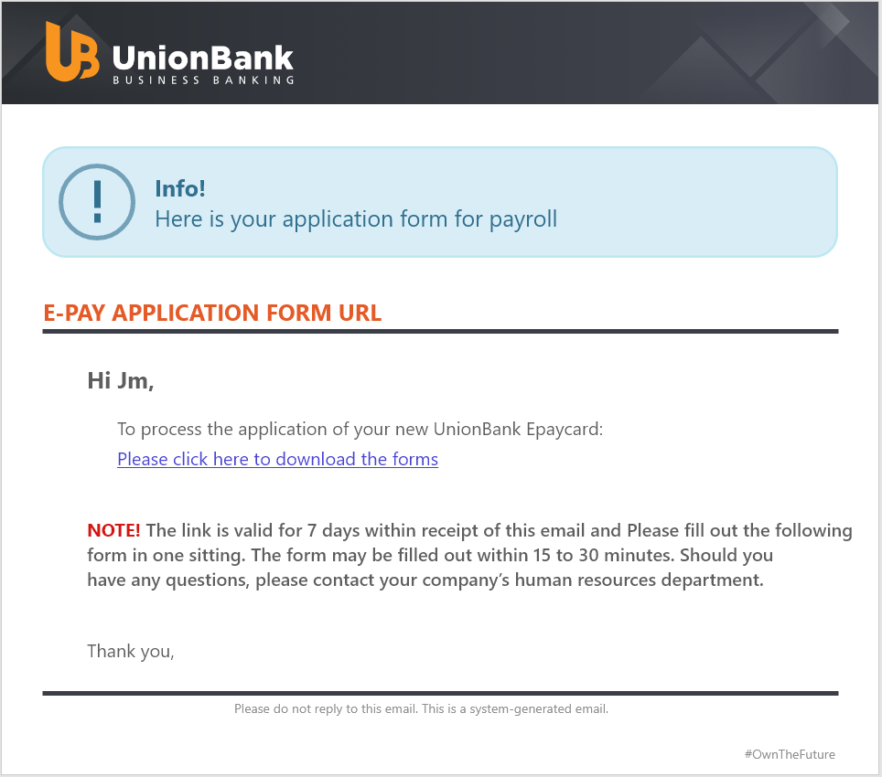

**ACCOUNT CREDENTIALS**

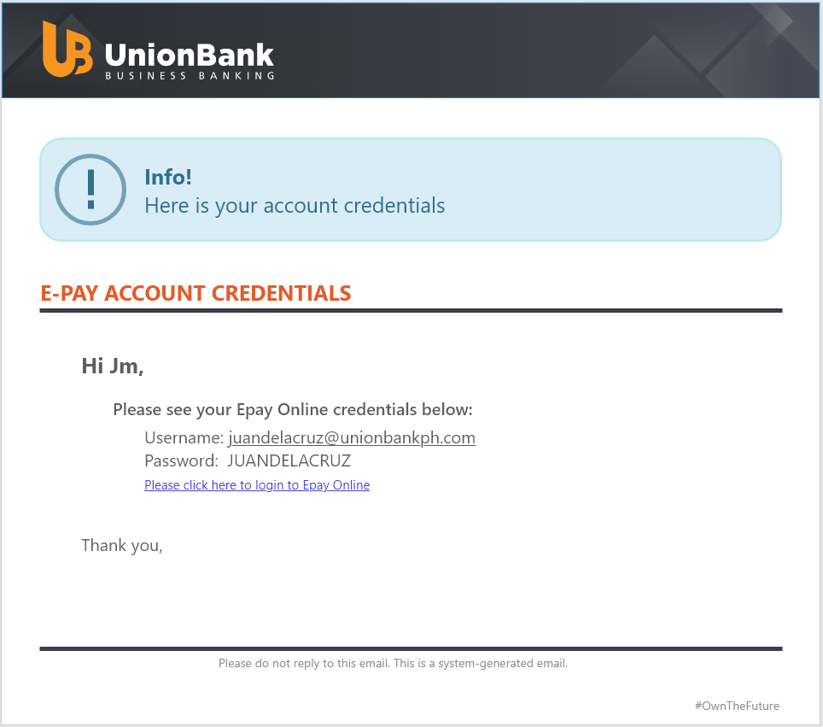

**REJECTED APPLICATION FORM**

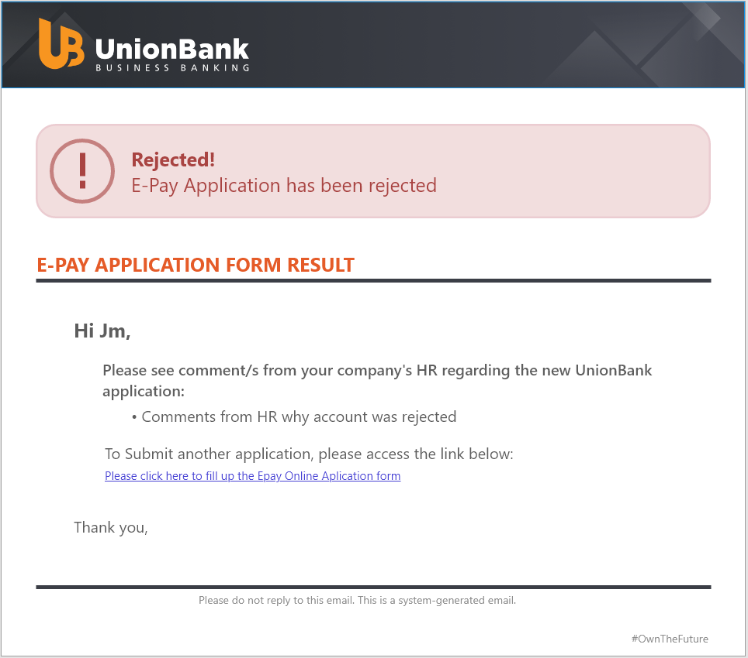

**ONE TIME PASSWORD**

